**General Sir John Kotelawala Defence University**

**Faculty of Engineering**

**Department of Electrical, Electronic and Telecommunication Engineering**

**Image Processing and Machine Vision**

**Assignment 02**

**Fitting**

Name: MPSM Pathirana

Reg No: D/ENG/22/0061/EE

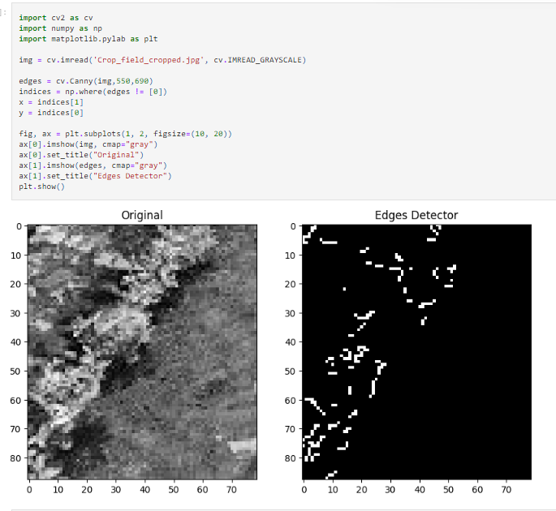**Question 01**

**Question 02**

**Question 03**

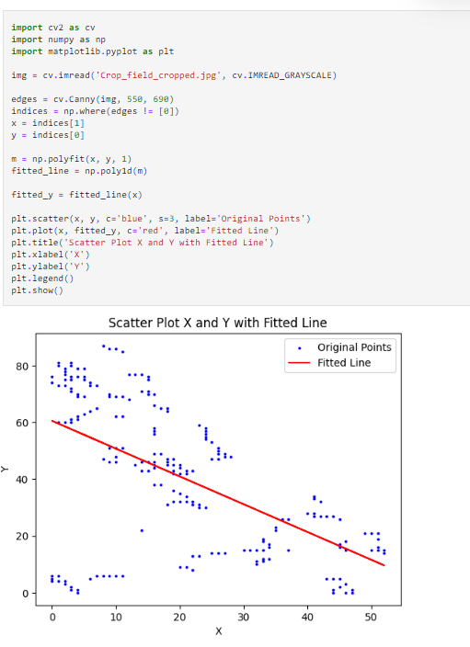

**Question 04**

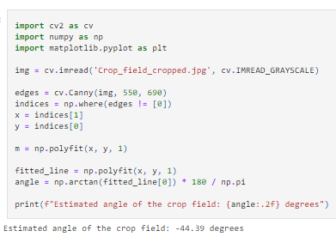

**Question 05**

No. If the scatter plot points are not distributed symmetrically and the line is not fitted correctly, it can significantly impact the accuracy of the estimated crop angle using the least-squares-fit line method.

**Question 06**

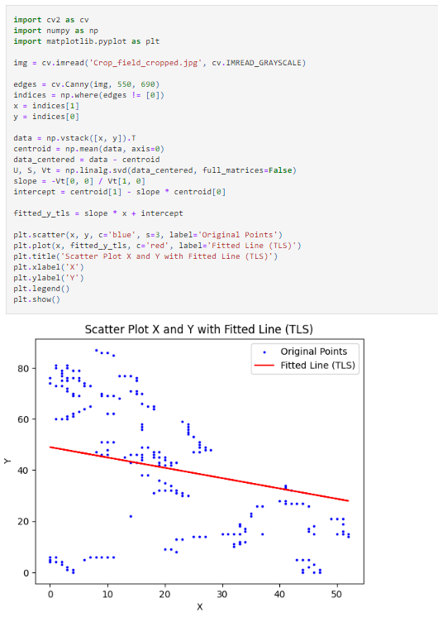

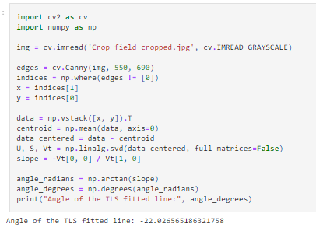**Question 07**

**Question 08**

**Question 08**

If the scatter plot points representing elevation data across the crop field are not symmetrically distributed and the line fitted using the total least-squares-fit method is not aligned correctly, it can significantly impact the accuracy of the estimated crop angle.

**Question 09**

RANSAC Algorithm

**Question 10**

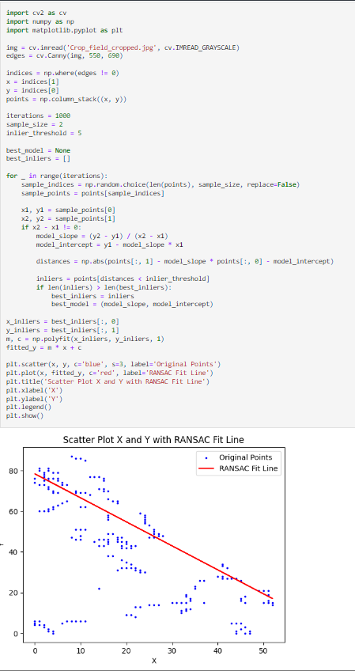



**Question 11**

**Question 12**

The RANSAC method is recommended over standard least-squares-fit procedures because it is more resilient to outliers and noise in the data. It accomplishes this by iteratively fitting models to subsets of the data, which allows it to remove outliers while providing accurate parameter estimation. RANSAC is adaptable in model fitting, accommodating models other than linear ones. It adjusts to various data properties and is appropriate for use in real-world scenarios. However, it can be computationally costly and does not guarantee finding the globally best solution.

Git Hub Link : <https://github.com/Sandeepa0/Image-Processing.git>